Patient Master

When a patient is comes to hospital , firstly we have collected the demographic details of the patient like Name, Consulting Doctor, TPA/ Sponsor/ Class, Reference Doctor(if Any) and charges Type (Normal charges, Day or Night Emergency).
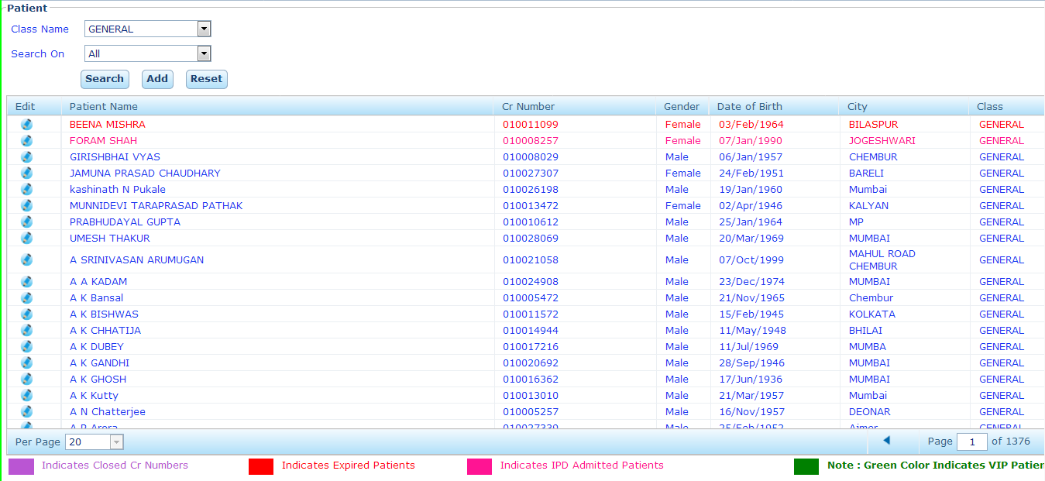
We can find the already registered patient from patient master by either their name, CR No, Company No. Mobile No. etc. by their class.
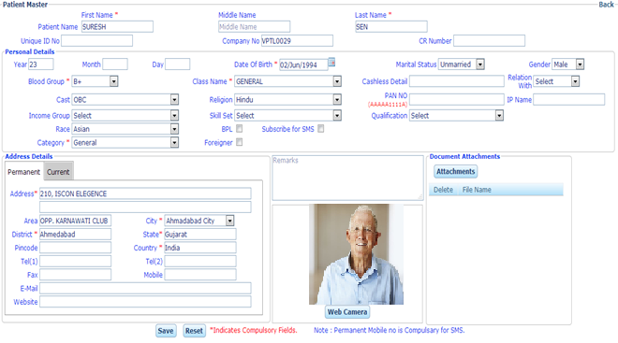
When a patient visits first time in the hospital we have to register the patient by collecting demographic details
Enter the Demographic Details of the Patient as follows:
- Patient Name: First, MIddle and Last Name
- Age/ Date of Birth
- Marital Status
- Gender
- Class*
- Blood Group
- Religion
- Category *
- Address: Current and Permanent Address with Area, City, District, State Country.
- Mobile No.
- Web Camera*
- Document Attachment*
- Category: We have categories the patient into General or VIP Patient. If we have mark the patient as VIP then we have Alert of "Handle with Care" at any transition phase in HIMS.
- Web Camera: We can capture the patient picture at the time OPD Registration via Web Camera by easy click.
- Class: Patient have the different Health Insurance Policy and they belongs from deferent class like General, Cashless, Cashless Reimbursement, Cashless Non Reimbursement and Co-Pay.
- Cashless Details: To fill the referral Number or TPA ID.
- PAN No. To fill the PAN No. of the Patient.
- Relation With: Relation of the Patient with the Insurance Card Holder.
- IP Name: Name of the Insurance Card Holder.
- Subscribe for SMS: SMS has to be send or not.
- BPL: if the Patient is belongs to BPL Category.
- Foreigner: if the Patient is foreigner.
- Email: to enter the Email is the Patient.
- Count: It represent doctor’s patient count.
- Browse: We can attach the document related to the patients.
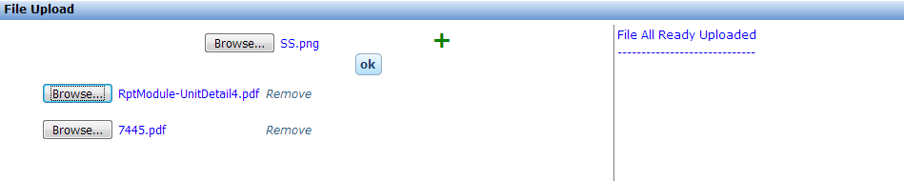
- Document Attachment: We can upload the patient document like previous prescription, referral letter of Reference doctor/ Insurance Company or Organization ID Card.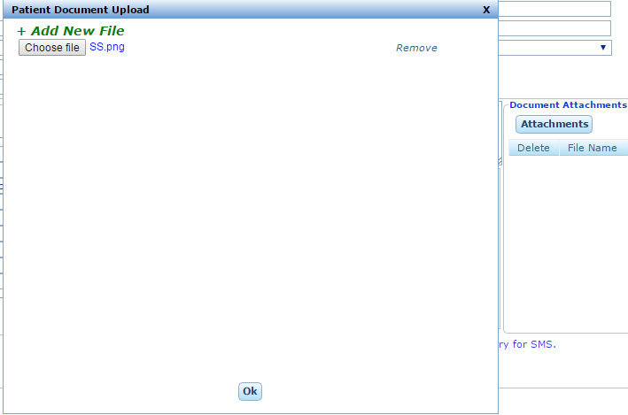
- Patient History: To view the patient previous History.
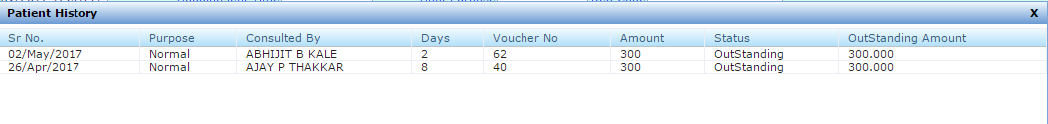
- Client Public Doc: To view the client public document.
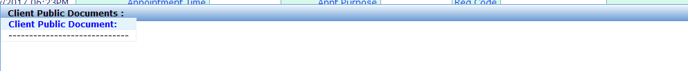
- Urgent: To take patient in priority basis. This not equivalent to emergency but takes on priority.
- Add Ref Doc: When reference doctor is not listed in reference doctor list we can add by click on Add Ref Doc with filling the details of referring doctor.
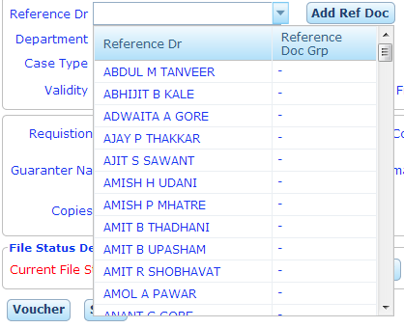
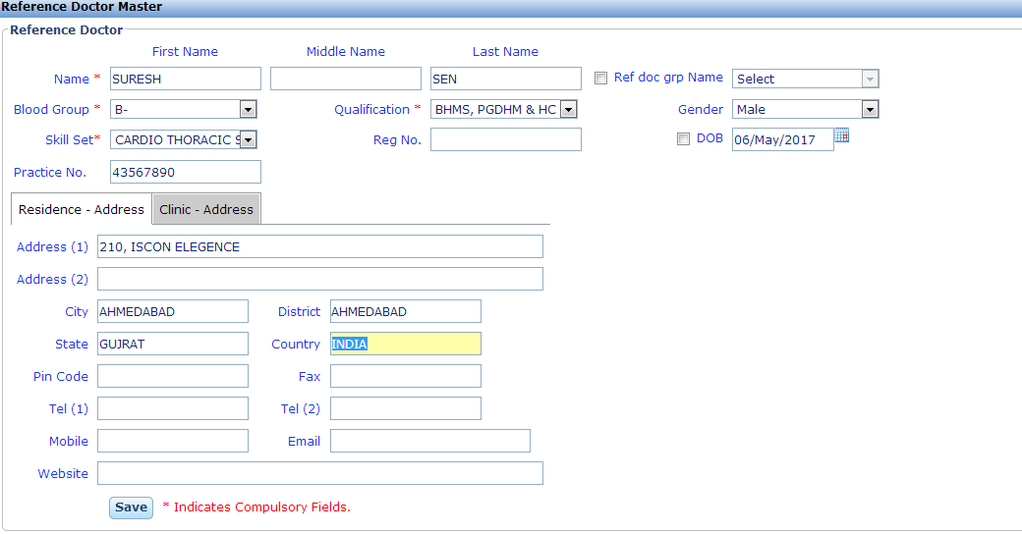

Doctor Master
To add a new consulting doctor, we have to add the doctor in employee master (Internal/ External) and set the category as doctor. Doctors are reflected from the employee master whose category is selected as doctor.

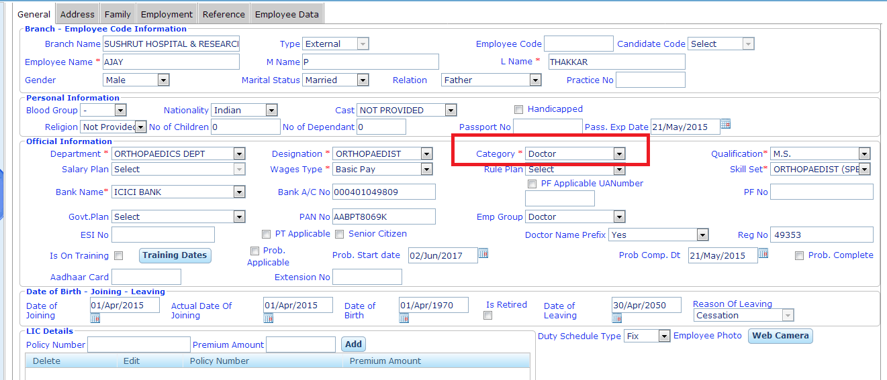

Reference Doctor Master

To add a new referring doctor, we use the reference doctor master.
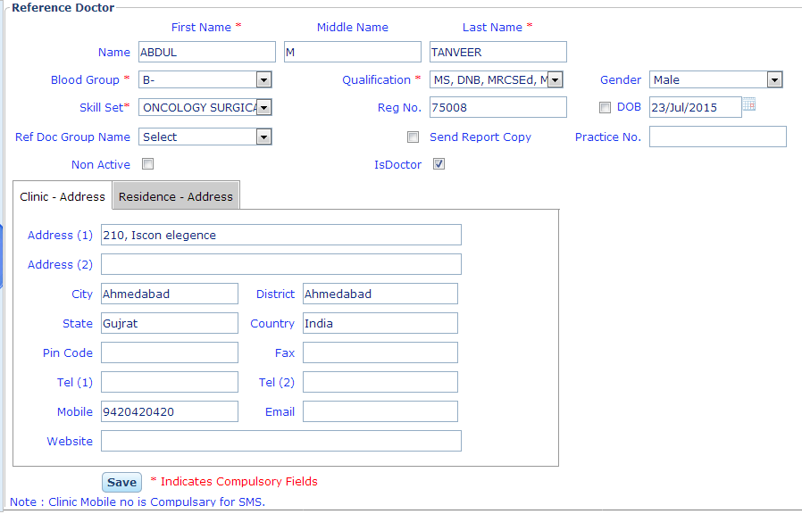
For this we have to add the following details of the referring doctor:
Doctor Full Name: Enter the Full name of the doctor.
Qualification: Enter the Qualifications of the referring doctor.
Skill Set: Enter the skills/ specialty of the referring doctor.
Registration No: Every doctor has their registration no for their doctorate.
Reference Doctor Group Name: Enter the group of referring if any.
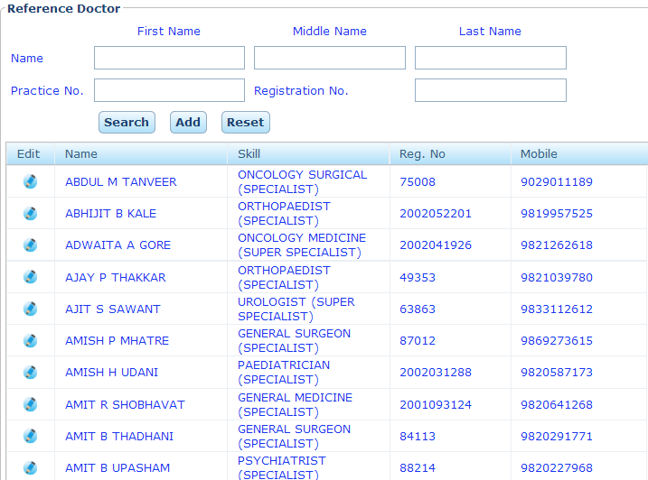

Client Master

Client Master is used to create a client. A client can be a TPA, Govt. Organization or private company for which the hospital have a tie-up.
Note: A Client can have more than one classes but reversal is not possible.
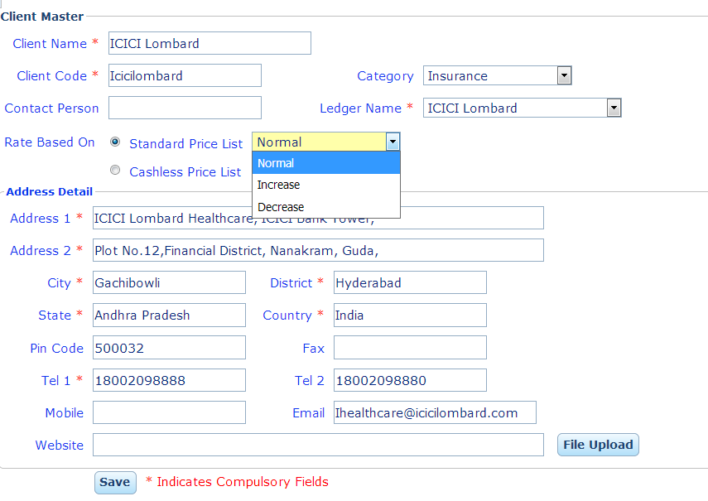
Client Name: Enter the name of the client that we have to add a client.
Contact Person: Name of the person of the client for communication
Ledger Name: Associate the client with their ledger for accounting purpose.
Address Details: Fill the detailed address with Mobile no., email ID and Website of the client.
Category: Select the category of the client like Insurance/ Corporate, trust or charity etc.
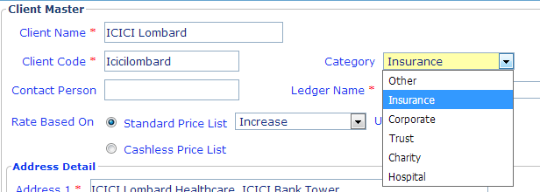
Rate based on: Set the rate list of the services/ service charges for the client.
- Standard Price list: if the tariff of the client is same like hospital tariff then select the standard price list.
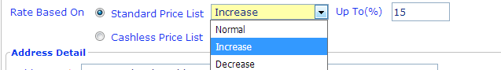
- Normal: When the tariff of the client is same as the standard tariff of the hospital.

- Increase: When the tariff of the client is more than the standard tariff of the hospital. We have to enter the increased amount of the tariff.

- Decrease: When the tariff of the client is less than the standard tariff of the hospital. We have to enter the increased amount of the tariff.
- Cashless Price List: When the client have their own list of services and charges/ own tariff list.
Client List: We can view the all the client list in client master.
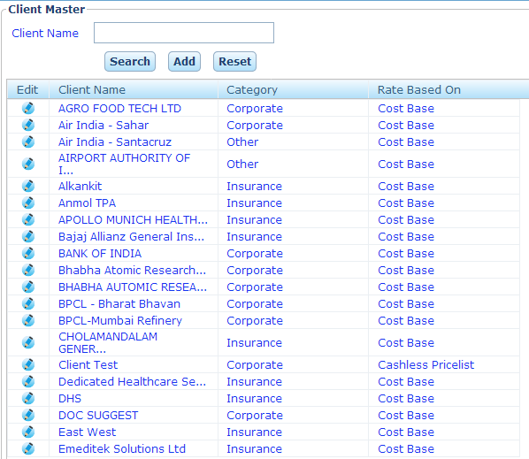
Search: We can search the client by their name in client master.
Add: To add a new client in client master.
Reset: To reset the client master text box.

Class Master

Patient have the different Health Insurance Policy and they belongs from deferent class like General, Cashless, Cashless Reimbursement, Cashless Non Reimbursement and Co-Pay.
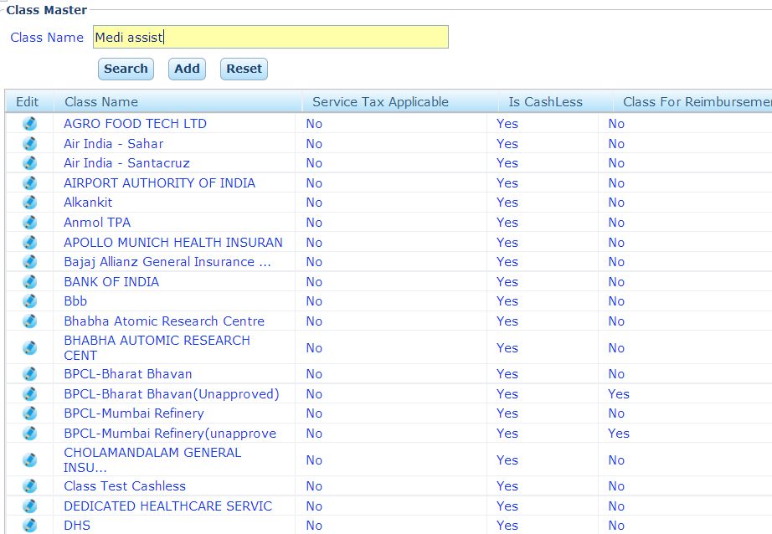
Search: We can search the client by their name in client master.
Add: To add a new client in client master.
Reset: To reset the client master text box.

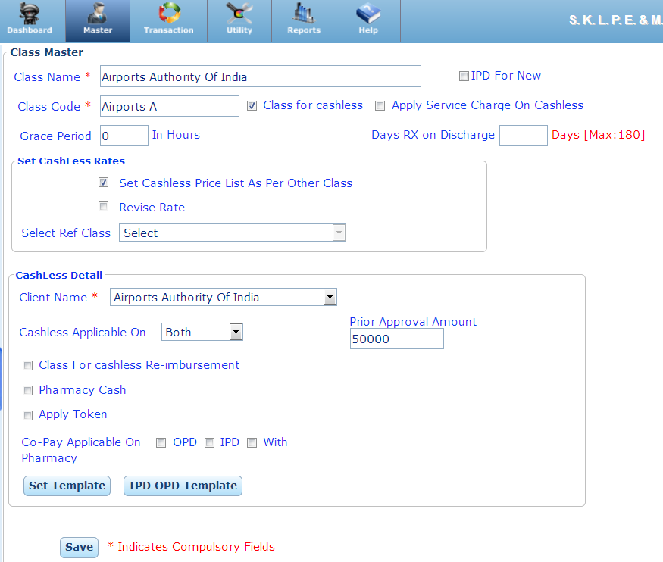
- Class Name: Enter the name of the class of the client.
- Class Code: Enter the code for class
- IPD for New: If cashless Rate List is used then enble the IPD for New. This enable when class is applicable for IPD. Here we can put the rate list of class manually for IPD patients irrespective of the standard tariff.
- Class for cashless: check enble if class is cashless.
- Apply Service charge on cashless: check enble if service charges(tax) on cashless for the class.
- Grace Period
- Prior Approval: Some times we have to take the prior approval to prvide the serive form the repective TPA . We can set the limit of prior approval.

Service TAX Details:
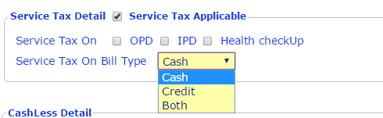
- When the service TAX is applicable for the class then check on “Service Tax Applicable”.
- Select Service Tax On “OPD / IPD Health Check UP”.
- Service Tax Applicable on Bill Type Cash/ Credit/ Both.
Cashless Details:
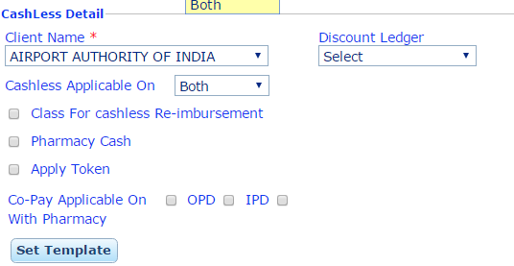
- Client Name: Select the name of the client of the class.
- Discount Ledger: Select the ledger for discount given to the class/ TPA. (For accounting effect)
- Cashless Applicable on OPD/ IPD / Both: Select On what cashless class is epplicable on OPD, IPD or both.
- Class for cashless Re-imbursement
- Pharmacy Cash: When pharmacy is on cash for the class.
- Apply Token:
- Co-Pay Applicable on OPD/ IPD/ with Pharmacy: When a class is type of co-pay then check the co-pay applicable on OPD, IPD or With Pharmacy.

- To copy the tariff of one clss to another class.
- For this check the “Set cashless Price List As Per other Class”.
- Select the reference class of which we have to coppy the price list into new class.
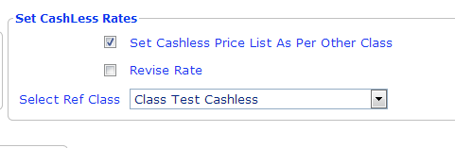
- Revised Rate: It is used when we have to revised the rates of parant class into their dependent class.
For Example: We have copy the price list of class A into Class B.(Class A Class B)
Now we have revised the rate of class A.
Note: Class B is dependent of class A and we have change the price list of class A, then we have to revise the rate of the class B.
Then We use Revised Rate on class master and select the reference class.
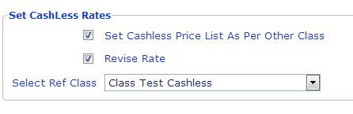

- General Class (Cash Patient): When a patient does not belongs to any Health Insurance Policy. He will pay the according to hospital charges either Cash/ Credit/ Debit Card / Cheque.
- Cashless: When a patient belongs form a TPA which provide the cash less facility. For this Patient can have the Referral Letter from their TPA. Patient can't pay any money for this their TPA is responsible for payment. Note: When the Background is green it indicates the cashless class.
Note: To create a cashless class check the “Class for cashless” and “Apply service charges on cashless”.
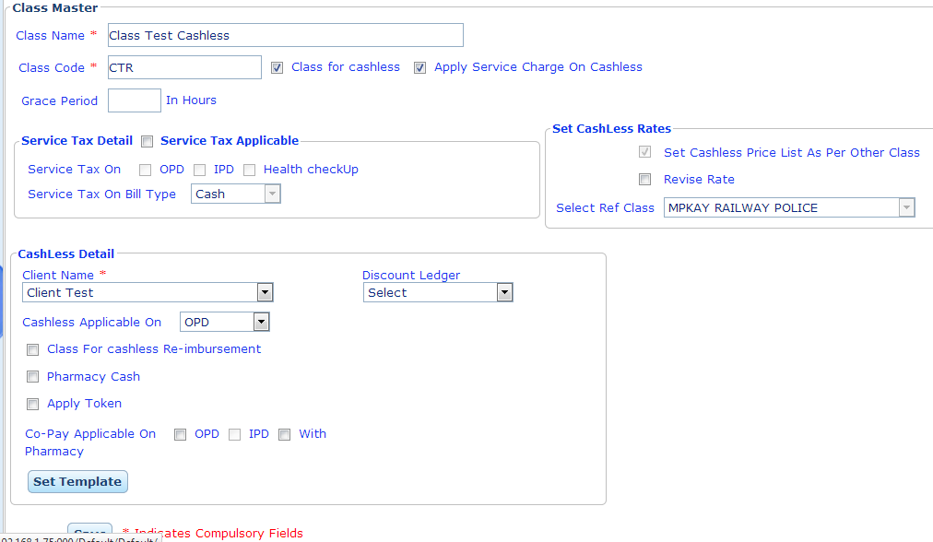
- Cashless Reimbursement: For this type of class, Patient pay the amount at the time of billing and they can reimburse the bills form their respective Company, Organization or Insurance Company.
Note: To create cashless Reimbursement class: check the following buttons:
- Class for cashless
- Apply service charges on cashless
- Class for cashless Re-imbursement
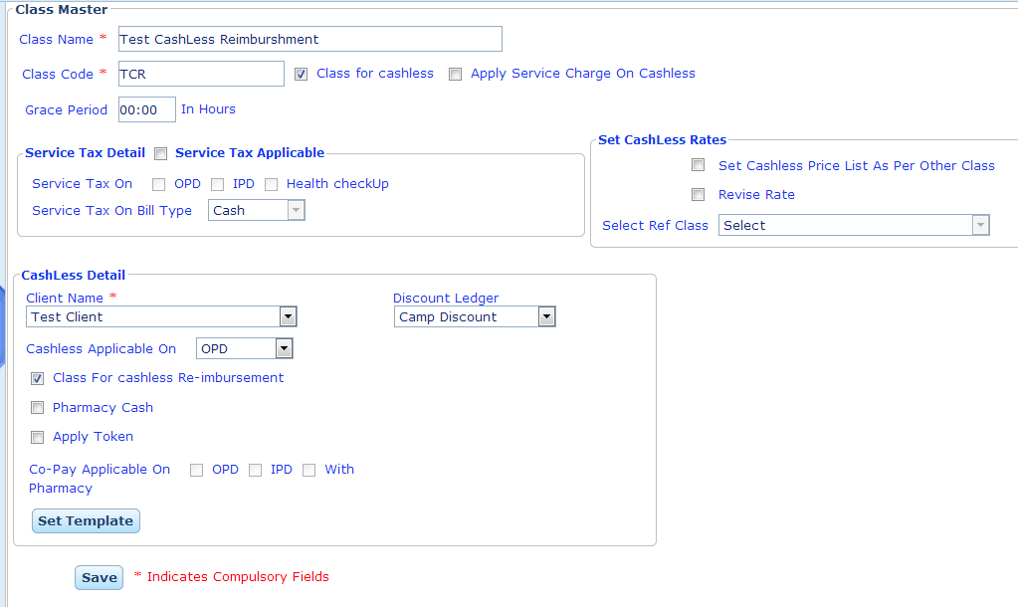
- Cashless Non Reimbursement: There are some services that are not reimbursed by the TPA for that patient will pay the bill and the bill was not reimbursed by the TPA.
Note: For cashless non reimbursement we have to check the non-cashless, it will be treat as cashless non re-imbursement.
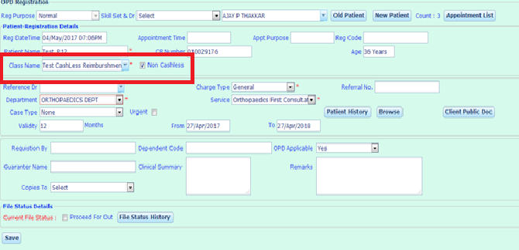
- Co-pay: When the patient belong for the Co-pay Class, the Bill will be paid by both the party’s patient and the TPA as per the ratio in the policy like 50:50, 60:40 or 70:30.
Note: For Co-pay Class we have to check the following things in Class Master
- Class for cashless
- Co-pay Class Applicable On OPD/ IPD / with Pharmacy.
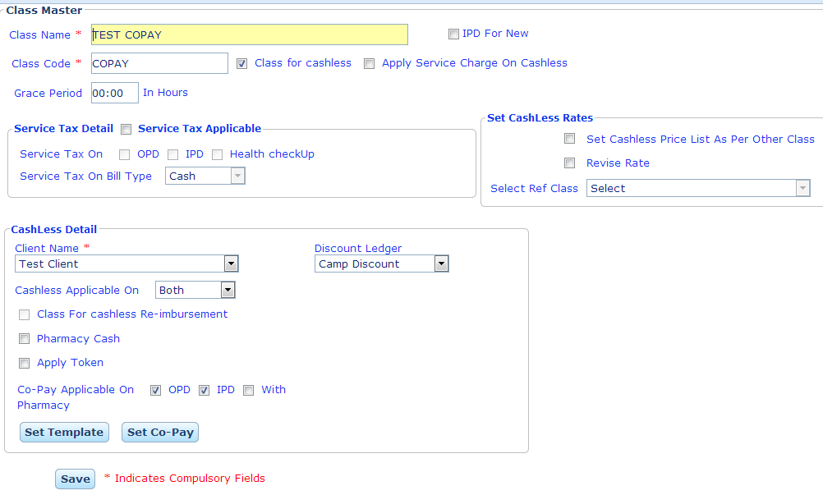

Cashless Price List
Cashless price list is used to copy the rates for the services for a particular class. We can copy the standard tariff (General class) by Normal / Increase / Decrease in percentage or enter the rate of services manually one by one according to the service type Wise.
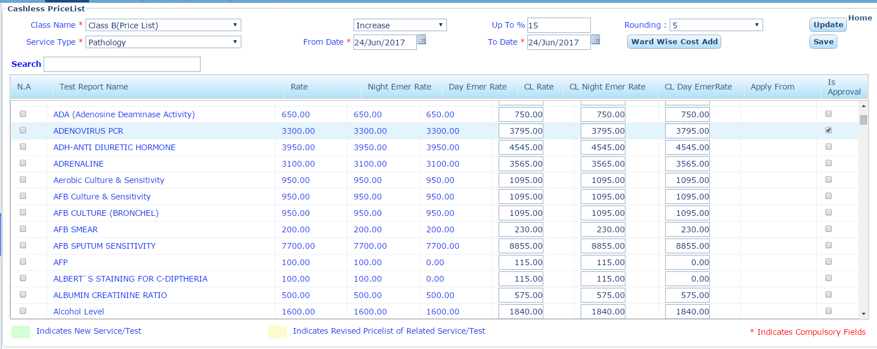
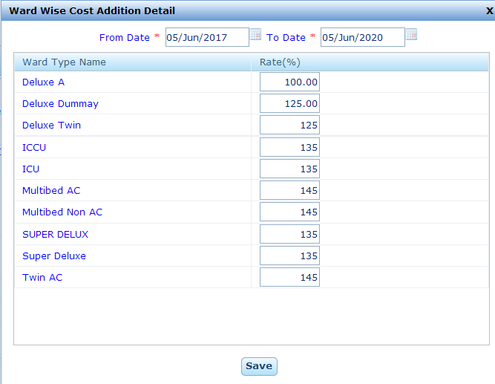
We can add Ward Wise Code Addition with the Cashless Price List. We can set the rated in either percentage/ rupees for the different wards.
Note: In Price List we can insert rates of service in OPD, Day & Night Emergency and IPD (WWCA) where as in Cashless Rate List we can only insert the rate for IPD. We can’t copy the standard tariff into another class.
Note: Some list of service are not provided cashless facility by TPA’s. For those service we can set Not Applicable in price List.
Copy Rates:
We can copy the standard tariff into another class by same rate, increasing/ decreasing in percentage to the standard tariff by service type wise.
Service Type: We can copy the standard tariff into another class service type wise.
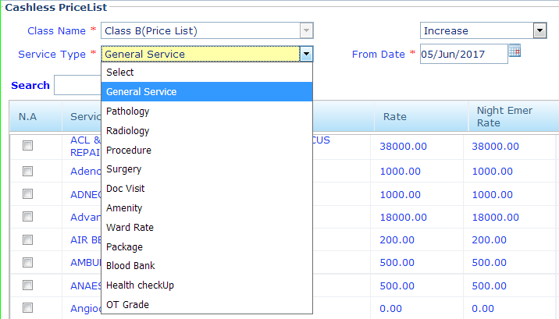

Is Approve: Sometimes there are some services for which we have to take the prior approval from the respective class/ TPA/ Insurance Company. For this we have a provision to check “Is approval” for those service in cash less price list.
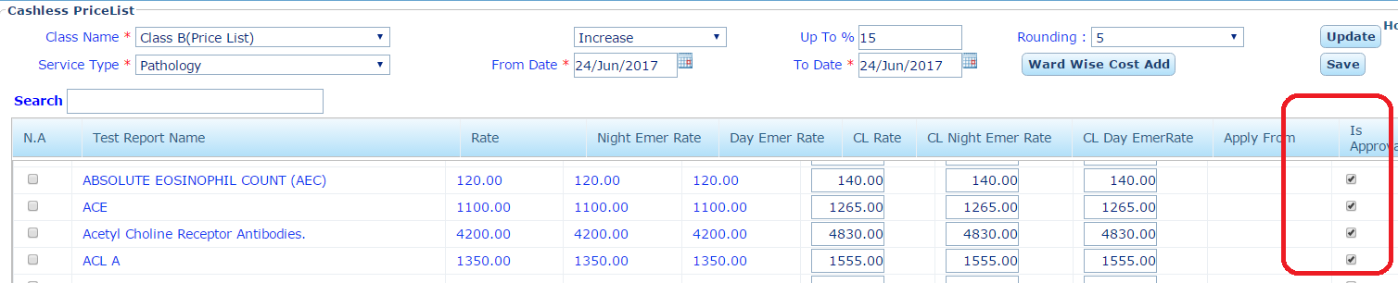
Note: After getting the approval from the Insurance Company/ TPA, We can mention that requested services are approved or not in the cash less approval.
Note: We have to mention Approved or not for the service which need the prior approval. If we not mention we can’t discharge the patient.
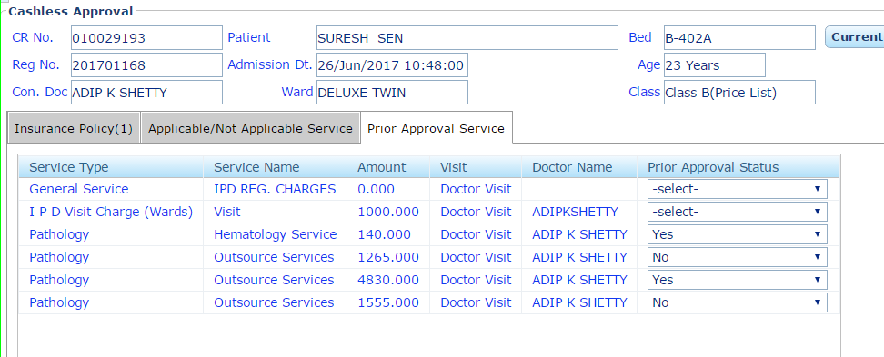
Revised Rate:
Sometimes we have to revise the rate of a class then we can set the effective date for current tariff and then from next day, we can set new tariff with new effective date.
For Example: If we have to revise the rate from 1st July 2017 then set the current tariff till 31/06/2017. Then set to date to 01/07/2017 to from date.
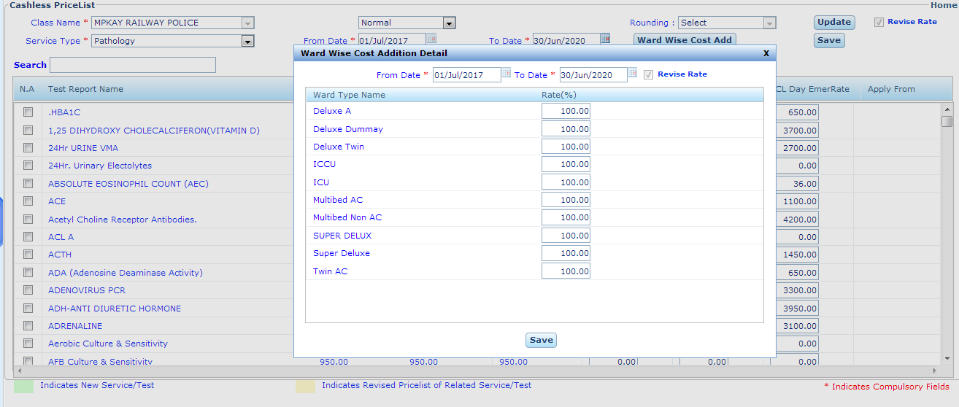



Cashless Rate List
Cashless Rate list is used to manually insert the tariff of services by service type wise for a class for different wards as Ward Wise Cost Addition (Only IPD).
Cashless Rate is list is used to insert the rates for IPD only via WWCA independent from the standard tariff.
Note: In cashless rate list only those classes are list for which button of “IPD for New” is checked in Class Master.
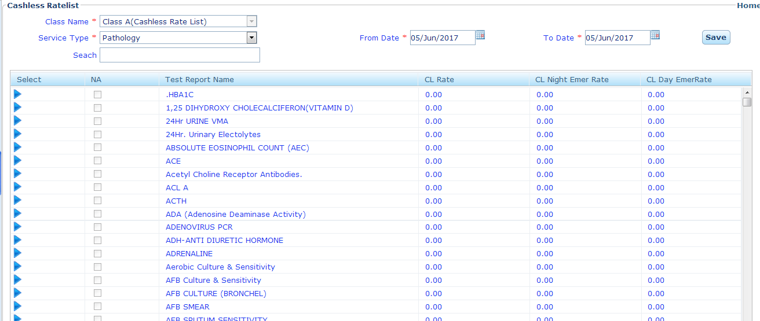
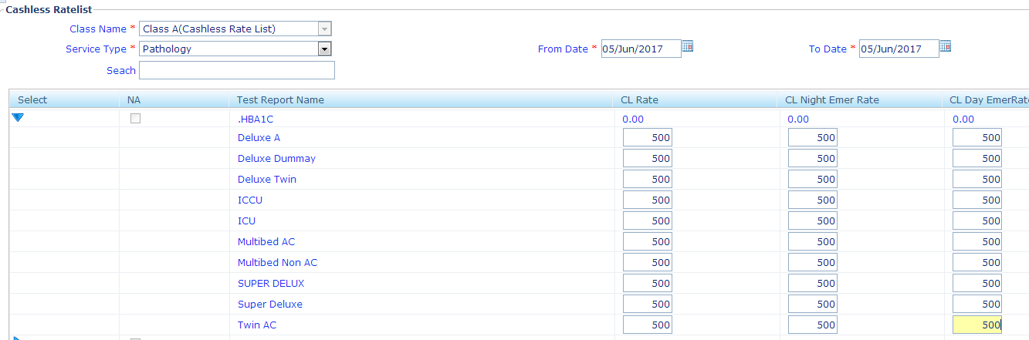

Revised Rate: Sometimes we have to revise the rate of a class then we can set the effective date for current tariff and then from next day, we can set new tariff with new effective date.
For Example: If we have to revise the rate from 1st April 2020 then set the current tariff till 31/03/2020. Then set to date to 01/04/2020 to from date 31/03/2022.
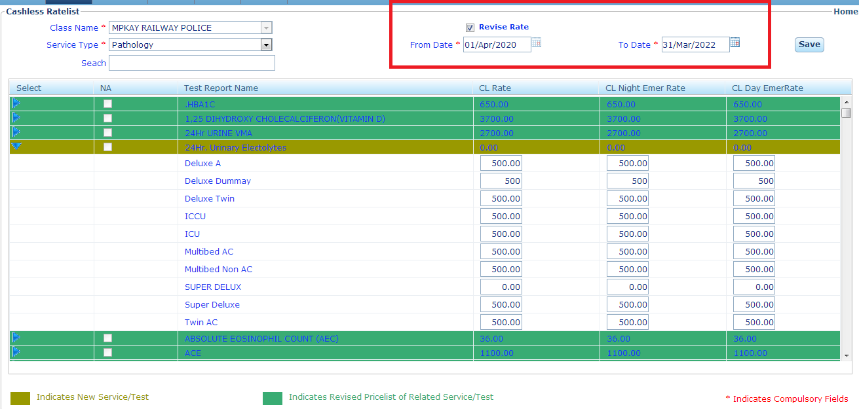



Service Master

Service Master is used to create the services provided by the hospital. To create the new service we have to enter the service type, service used for OPD/ IPD/ Direct, Name of the ledger, service rate and effective dates. Service Master shows the list of all the service.
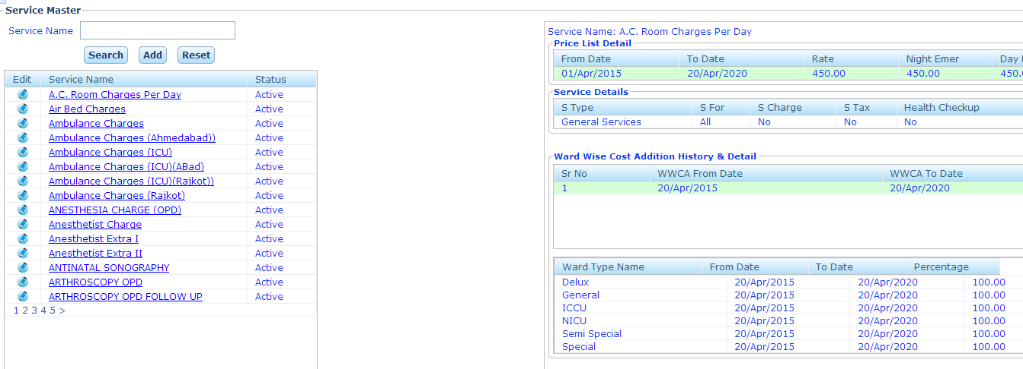
Search: We can find the service by its service name in Service Master.
Reset: To reset the service text box in Service Master.
Add: This is used to create a new service.
Note: Current Price List and Ward Wise Cost Addition Price Listed in Light Green.
It also show the history and detailed information about the service. Like
Price List Details: It shows the previous History of Price List.
WWCA History & Details: It shows the previous History of WWCA.
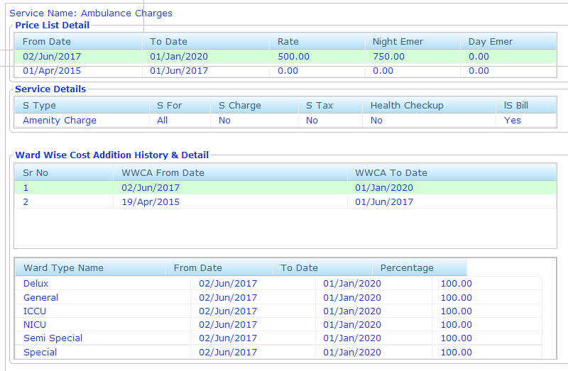
To create a new Service in Service Master:
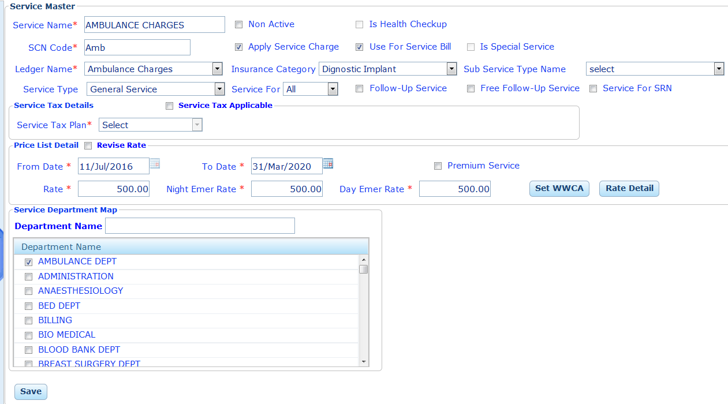
Is Health Check Up: Checked enable When the New service is a Health Check Up.
Apply Service Charges: Checked enabled when service charge is applicable.
Use for Service Bill: Checked enabled when new service is used for service bill.
Is Special Service: Checked enabled when new service is a special kind of service
Ledger Name: select the name of the ledger from which service belongs for accounting purpose.
Service Type: select the type of the service consultation/ visit type/ Pathology / Radiology/ Procedure/ General Service/ Pharmacy/ Misc. charges etc.
Sub Service Type Name: Select the name of sub service type.
Service Used for OPD/ IPD/ Direct/ All: select for which service is used.
Follow up Service: Checked enabled when new service is used for a follow up service.
Free Follow up Service: Checked enabled when new service is used a free follow up service.
Service Tax Applicable: Checked enabled when service tax is applicable on newly created service.
Service Tax Plan: If service tax is applicable then select plan of service tax.
Rate: Enter the rate of the new service.
Night Emergency Charges: Enter the night emergency charges.
Premium Service: Checked enabled when new service is a premium service.
Department Nam e: Select the name of the department from which service is belongs.
Service for SRN: Check Enable if the entered service is used for Service receipt Note.
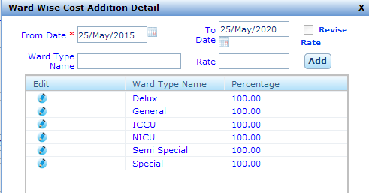
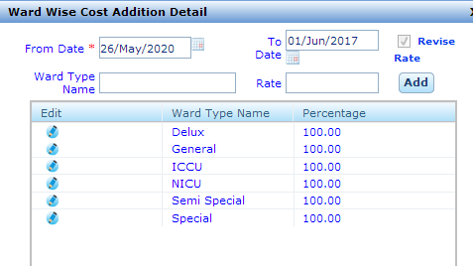
Revise Rate: if we want to change the rate of service effective from a particular date then we have to be used revise rate.
For Example: If we have to revise the rate from 1st July 2017 then set the current tariff till 31/06/2017. Then set to date to 01/07/2017 to from date.
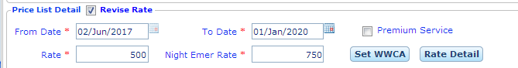
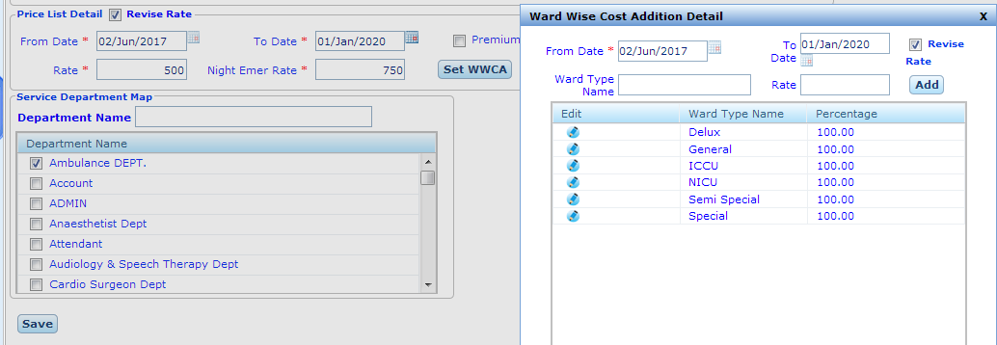

Department Master
Its represent the list of hospitals departments and department assign to respective employee.

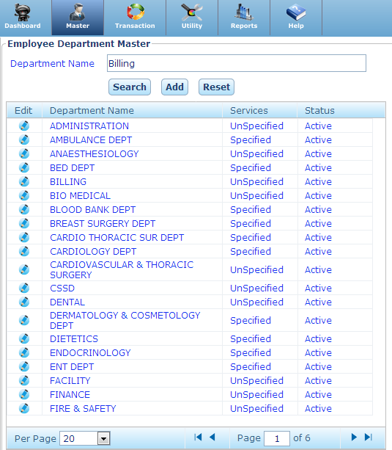
(1) Search: - We can see any department details which already enter in system and search via enter department name and search department name in the list and click on Edit and show department details on screen. We can set list of departments page wise like per page 20, 50,100 etc.
(2) Reset: - We can clear search text box using Reset Button.
(3) ADD: - If we want create new employee department than we add new employee department in list.
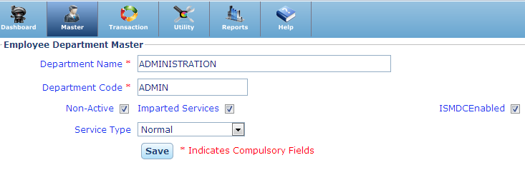
(a) Department Name: - Enter new department name.
(b) Department Code: - Enter department code, which will represent specific department.
(c) Service Type: - Select service type for department and show only those department which respective service type either normal or direct or both.
(d) Non-Active:- If department will not use in future than change department status from active to no-active.
(e) Imparted Service: - to allow department provide own services than check the box.

Mode of Payment Master
Mode of Payment Master is used to create mode of payment like cash, credit card, debit card, Multi-mode, paytm, or other smart payment mode.
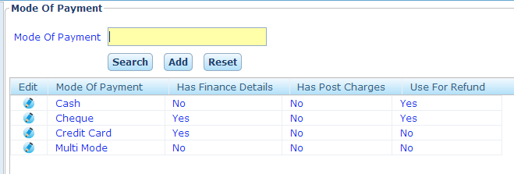
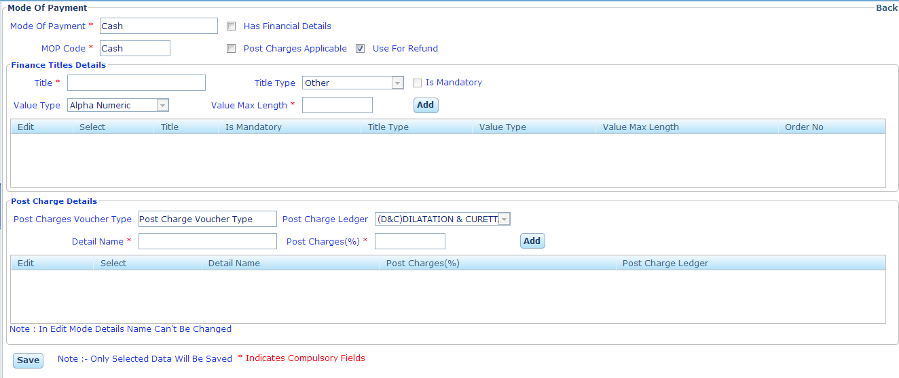
Has financial details: if the payment mode has the financial details then checked it.
Use for refund: If the payment mode is used to refund the amount.

Title Details for payment mode
Is title is mandatory: check if the title is mandatory.
Value Type: select the value type of title.
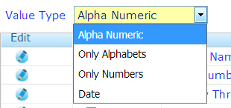
Value Max. Length: Enter the maximum length of the title.
Create the title details like:
Cheque: cheque No., cheque Date and Bank
Credit/ Debit Card: Transaction No., Card Holder Name, Card No. , Validity.
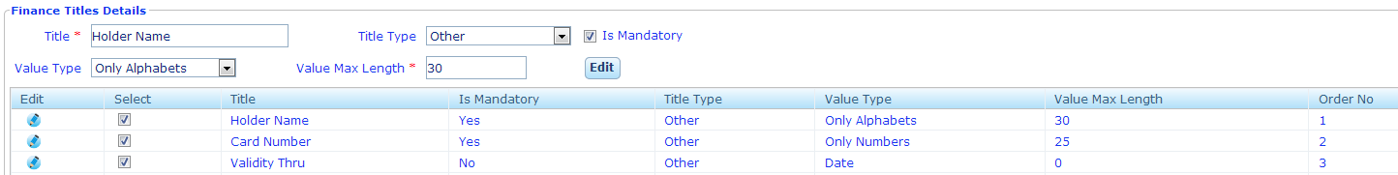
Post charges applicable: check when we have to collect the post charges.
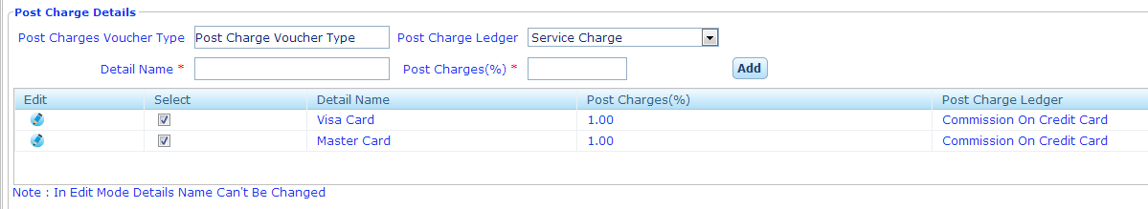

Cancel Reason Master

Cancel Reason Master is used to create the reason by which any transaction get cancel like IPD Admission, IP Admission Note, Discharge etc.
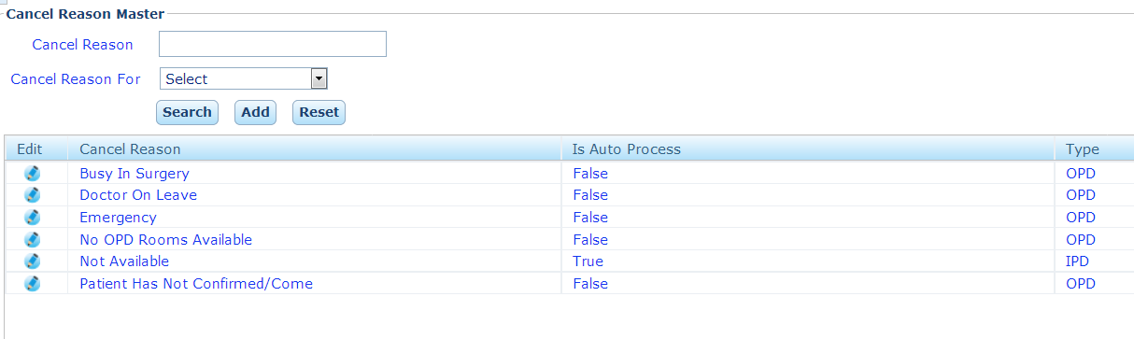
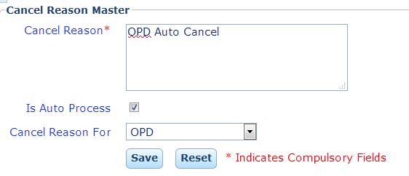
Cancel Reason: Enter the Name for Cancel Reason
Is Auto Process: Check if reason is auto Process. Auto Process means any transaction is cancel by system itself by occurring an event.
Cancel Reason for (OPD/ IPD): Cancel Reason is used for OPD or IPD.
Note: We can generate only one Cancel Reason for OPD and One for IPD.
Vaccination Master

It List out all the vaccine that will give to the child. We can add the name of the vaccine in to the vaccination Master.
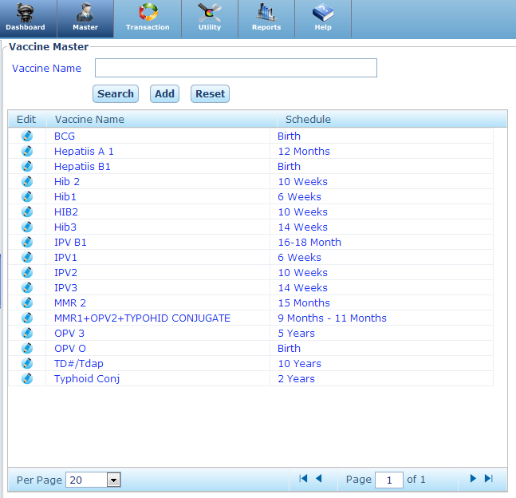
Add New Vaccine Master:
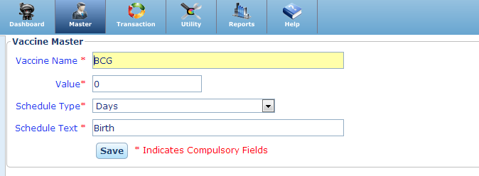
Vaccine Name: Enter the name of the vaccine.
Value: Enter the time value on which child get vaccine.
Note: Zero Indicate the time of the Birth.
Schedule Type: Select the schedule type from Days/ Month/ Year.
Schedule Text: Add the Caption for Schedule time.

